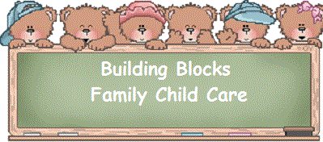
Hours of Operation
Monday-Thursday 7:30AM-5:30PM
Daily Schedule
7:30AM | Arrival and Greeting | Children wash hands upon arrival, diaper checks. Children sign in and play with table toys or read.
7:45AM | Centers | Children may choose from the weekly activity trays, reading, art, or table toys.
8:15AM | Outside Play | Hand wash, bathroom, and diaper checks. Free play and some group activities outdoors (time may be longer or shorter depending on weather)
9:30 AM | Snack | Hand wash, bathroom, and diaper checks.
10:00AM | Group Activity | Small group activity (science, social studies, literacy, sensory, dramatic play, cooking, or music)
10:45AM | Free Play | Children may do any activity they choose, lunch is prepared
11:15AM | Nap/Lunch Setup | Children get their cots ready for nap time and help serve lunch after washing hands.
11:30AM | Lunch | Hand wash, potty, diaper checks
12:15PM | Nap | Children nap or lay down and rest, non-nappers may choose to read after a reasonable time.
2:00PM | Quiet Activities | Children may choose to read or do puzzles until all children are awake. As children awaken, diapers are changed, they go to the bathroom and wash their hands. Free play once all children are awake.
3:00PM | Snack | Hand wash, bathroom, diaper checks
3:30PM | Creative Play | 1-2 times per week project art, 2-3 times per week process or free art
4:00PM | Centers or Free Play | Kids choice until departure

